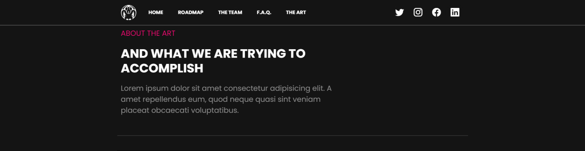

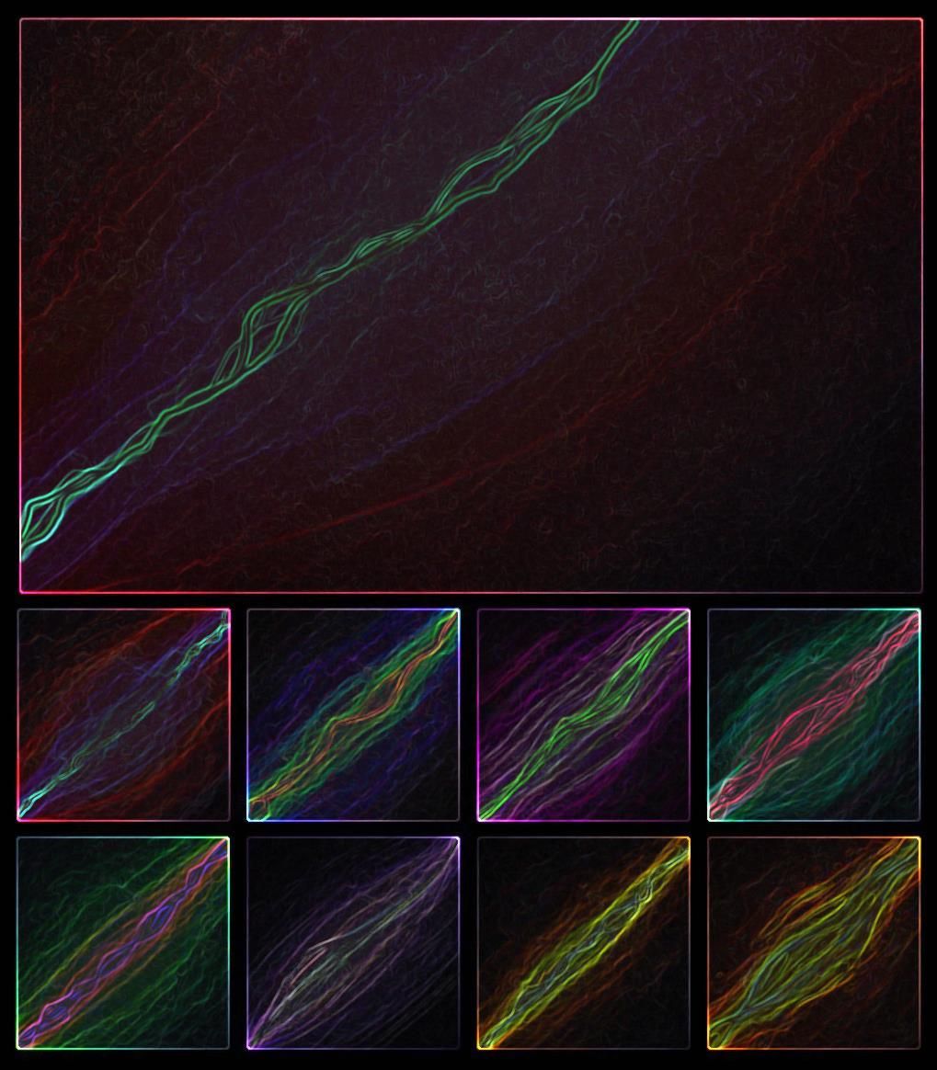

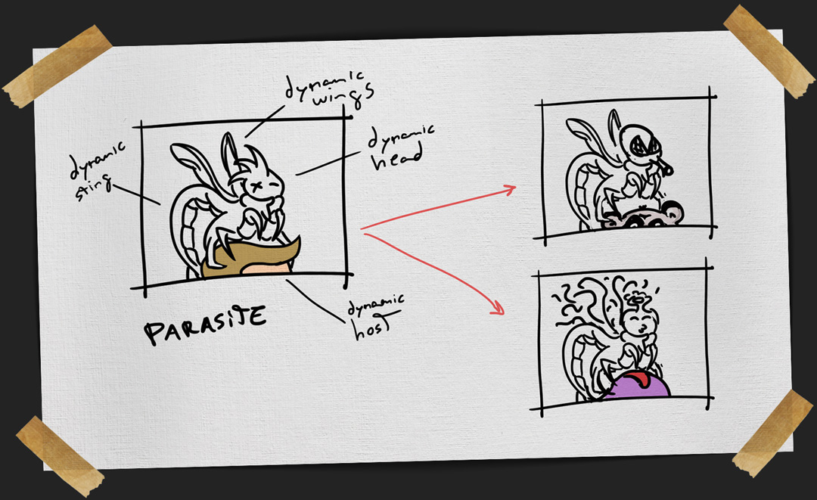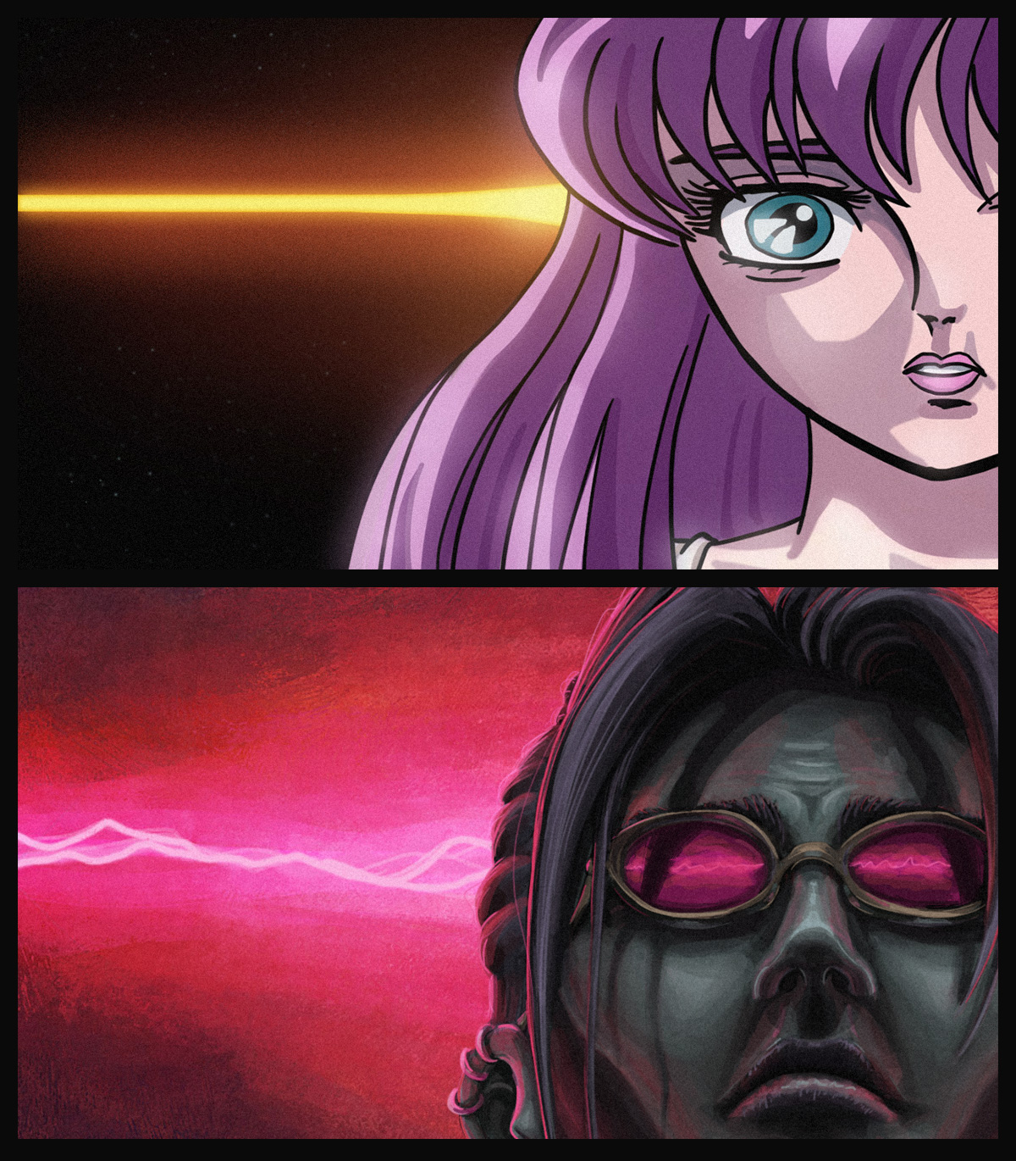

We felt like offering more than just a medium for speculation, that’s why **we bet high on creativity and the art itself**. We are, first and foremost, artists trying to express ourselves and to do creative work whenever possible.

That’s why every asset and every part of this project was crafted with hard work, passion and a style that tries to be an authentic representation of ourselves.

If you got this far we would like to give you our most sincere **THANK YOU!** And as a special easter egg, here is the very first sketch for this project, some lines that represent the start of something very fun.

Some final words

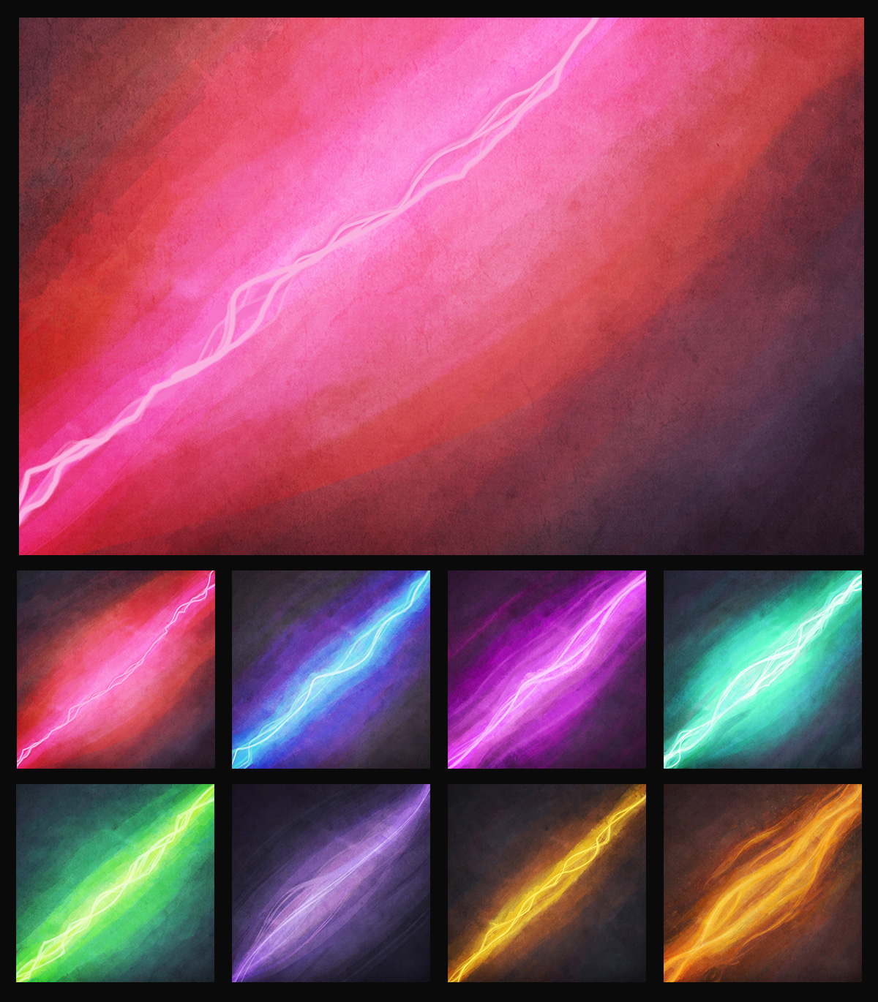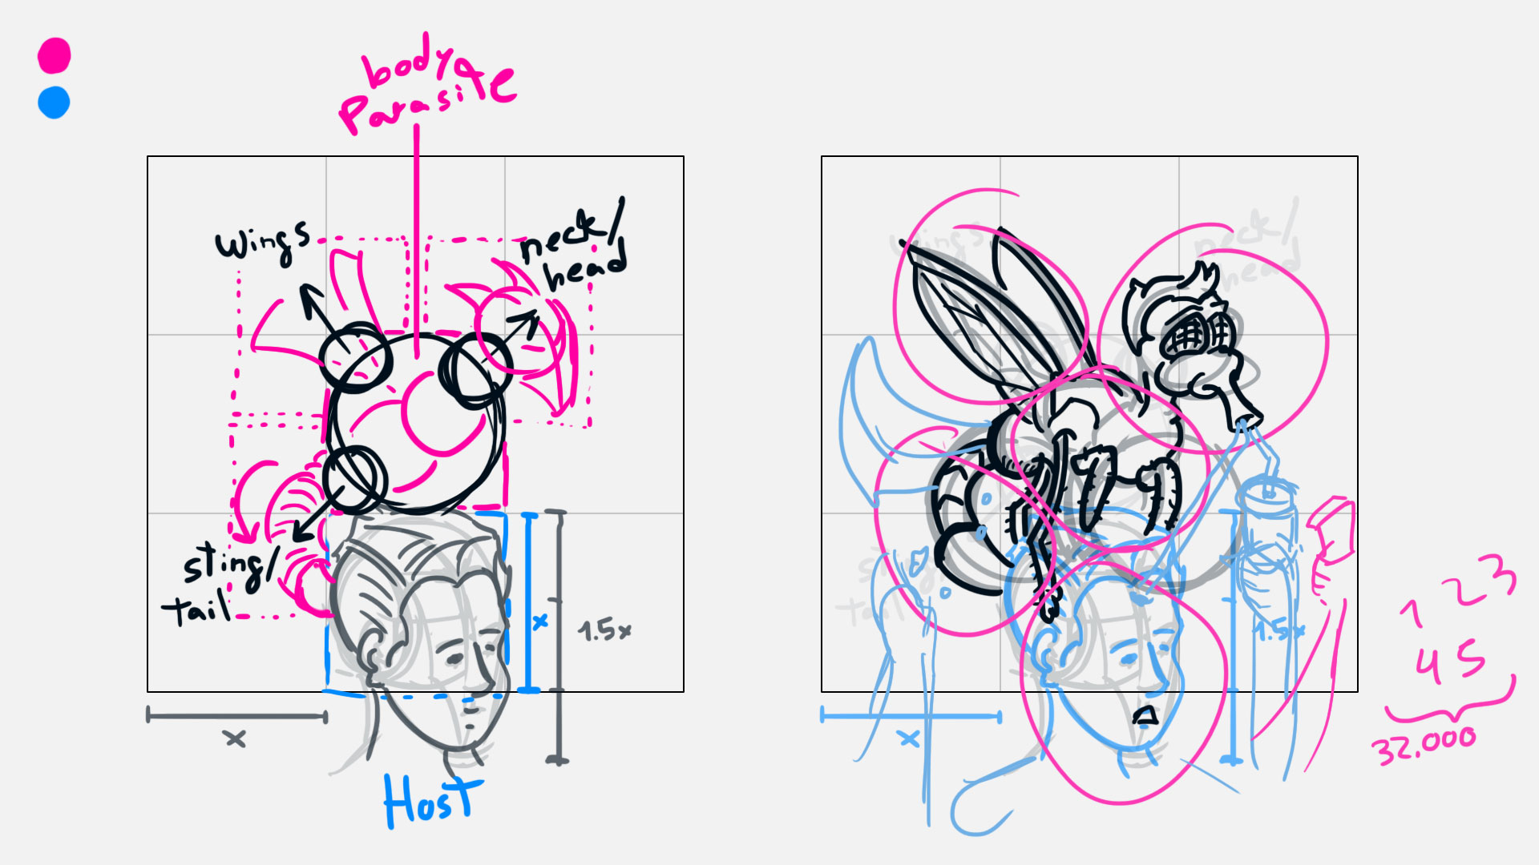

Probably the most distinguishing visual aspect of our art is the **intense diagonal in the background**.

It plays an important role bringing dramatic contrast to the piece. It’s there to represent a vivid **sense of perturbation**; an annoying buzz felt by the host, in a similar way of those we’ve already seen in several manga/anime to portray the same feeling.

Each background was carefully painted by hand, made to function in harmony with the whole list of parasite and host parts.

The background

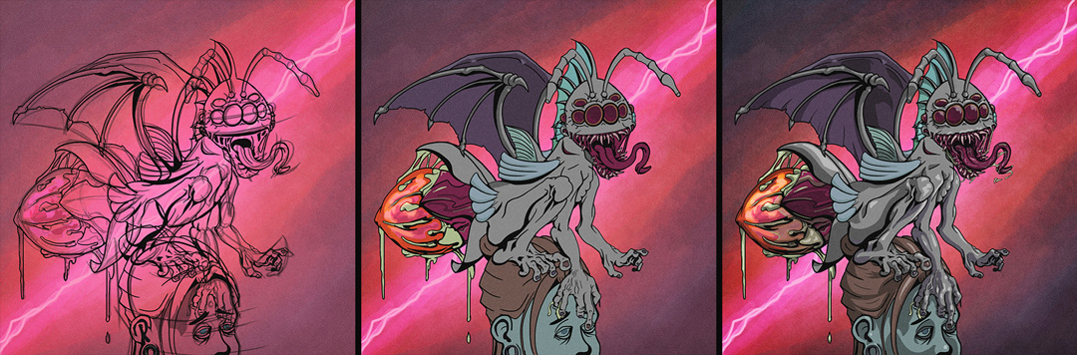

The foreground of the pieces is portrayed in **a classic cartoon style**. We went for hard edges and a limited palette consisting of three levels of intensity for each color: a neutral base, a layer for the shadows, and a layer for the highlights.

The choice of colors for both the parasite and the host was made to be neutral on purpose. We went for a dark and moody look and wanted the collection to have a coherent style across all the pieces.

The foreground

An overview

Our art is composed by several **assets designed to be procedurally assembled** into unique pieces depicting abhorrently grotesque parasites over their hosts.

The categories for these are:

* Parasite eyes,
* Parasite mouth,
* Parasite abdomen,
* Parasite antennae,
* Parasite tail,
* Parasite wings,
* Host hairstyle,
* Host eyes,
* Host ears,
* Host arms.

When brainstorming this project we arrived at the idea of giving a twist to the more common cute PFP furry avatar, our take was to **become the parasites** that feed on them instead.

That notion of trying to do something a bit different also impacted the art direction, in particular the color palette.

Instead of going for the same pastel tones we preferred a neutral palette for the protagonists and an intense oversaturated background to complement the dark mood for a **high visual impact** final result.